12/30/15
Shell Speed vs. Oar Lever Ratio
.o0|0o.
The ROWING model seems to show that there is an advantage to be gained through the use of a most efficient lever ratio (rig) in sculls. What may prove controversial is that this ideal ratio looks to be "heavier" than the ratios currently in vogue.
By lever ratio (Rl) I mean the oar Outboard/Inboard, as measured from the center of the sculler's hand force, to the pin, and to the center of pressure of the blade[1]. In terms of oar length (L) it is: Rl = (L -Inb)/ Inb. It is independent of the spread which has no meaning in relation to lever ratio.
For simplification in the examples run the half-spread is kept equal to the inboard; thus the handle center-of-force is always at the shell centerline when the oars are at 90 degrees.
In the model (ROWING) speed comparisons are made for several ratios (from 2.33 to 2.60) for an oar of length 2.69m. Change between ratios is accomplished by adjusting the inboard and the 1/2 spread by equal amounts, thus leaving the handle(s) always the same distance from the boat center line.
In the comparisons the following variables are held constant:
o Shell characteristics (except pin spread)
o Oar length and blade surface area
o Rower weight, height, and slide excursion
o Peak oar handle pull and force profile (the rower is never pulling more or less "hard"); he may be pulling slightly longer, but not as often.
o Length of the (longitudinal) draw from catch to release (catch and release angles vary)
o Total overall rower power(W) achieved by adjustments in rating.

In other words, everything is held constant but the variables of interest; something that is possible only in a computer model such as ROWING.

The result (Figure 1) seems to indicate that when the rigging is relatively light (long inboards, easy "feel") small adjustments show no changes in efficiency.

However, as the inboard is shortened ("hardened") overall rowing efficiency (shell speed) increases to some maximum and then falls off beyond higher ratios.

The complete program input and output data (including Figure 1) can be found in file CvsH_Stroke04.xls.

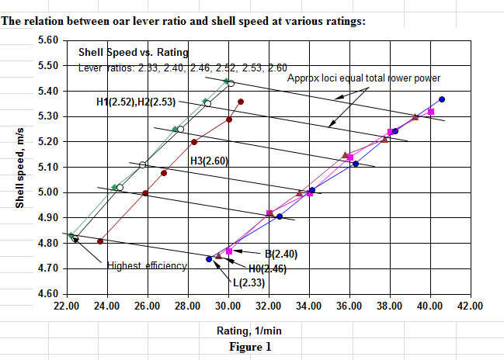

What is interesting is that, for equal power, the shell speed increases up to a point even though the rating (adjusted down for power equality) is less than the "base" rating. I attribute this mainly to an increase in rower efficiency; as much as 5% between base and heavier rigs. The difference in shell speed amounts to as much as eight seconds in 2,000m.

It may be important, too, that the shell advance per sweep (meters traversed between catch and release) is increased as much as 40% with heavier rigging owing to the increased sweep arc of the blade (105 degrees vs. 98 degrees) and an increased duration of the drive time (1.15 sec vs. 0.75 sec).

I fear that this advantage may be challenged as impossibly counterintuitive (rig heavier at a slower rating to go faster?), but it is what the ROWING model tells me.

Some background:

A year ago in September Joe Bouscaren
<https://www.youtube.com/user/JoeBouscaren>, an accomplished rower and coach, approached me with a stroke concept he had developed some time ago and with which he had once handily won the HOCR in his class. He was interested to find whether my model ROWING could recreate his stroke and confirm its advantage over the conventional wisdom of rigging.

His stroke had several innovative features which did not lend themselves easily to computer modeling but one stood out--the shortening of the inboard to produce a longer more deliberate drive. A drive has a sharp onset and instantaneous release and is long enough (1.00 sec vs. 0.75 sec) for the rower to have a sense of control over its progress.

And so I set about looking into the effects of lever ratio alone -- an easily modeled variable -- and the calculational results seem to confirm his idea. It seems that for the same rower power you go faster at 28 1/min rigged at 2.5 than you do at 36 1/min rigged at 2.4. This outcome seems shocking and I wonder whether it is real.

It is one thing to come to conclusions having made precise numerical calculations involving small changes in well-defined variables, and another to relate such findings to the messy world. The difference in inboard between the base case here tested and the apparent best case is only 0.31m (3.1 cm) much less, even, than the width of a rower's hand. It seems, then, that rigging to precise dimensions is an exercise in wishful thinking; according to my model the rower can effect a significant difference in his efficiency by a mere few centimeters shift in his position on the oar handle. According to this "shifting gears" is easy and perhaps the rower would be well advised to reduce his inboard a bit as he gets well under way in a race -- formal rigging be damned.

Another thing to wonder about -- for sculls -- is whether the computational best lever ratio for this case (0.763) would hold for many rowers sizes and strengths. Maybe one doesn't have to mess around much, just always choose 0.76.
Having the ratio too big or too small doesn’t work; maybe for each boat and rower there is a “sweet spot” to be found in the ratio.

So, do accurately timed splits over, and over, and over on your measured course (in still air and no current) and see which ratio your speed boss tells you is the fastest. It might turn out to be a "heavier" rig than you had expected.

.o0|0o.

[1] You can approximate (and mark) the blade center-of- pressure by cutting a piece of stiff cardboard to its outline and finding its center of gravity.

